**FLASK INTEGRATION DOCUMENT**

**Flask** is a web application framework written in Python.

# **Directory Structure:**

## **Project Directory >>**

* flask_service.py
* **Files >>**
  + roll_no.pkl (Model Pickle File)
  + roll_no.py (Preprocessing and Feature Engineering Python File)

# **Flask Zip File:**

* First and foremost download the Flask zip file from the noticeboard.
* Extract them and store it in the Project Directory.
* Rename all the files in the **FILES** directory by your roll_number.
  + Eg. 1405043.py → 18******.py
  + And the class name as well in that file.
    - class _1405043(): → class _18*******():
* Before you proceed with Flask Deployment, if you have applied multiple models in your notebook. Select only one and remember the features passed in that.
  + Eg. Linear Regression:
    - Features List: amount, days, mean, median.
    - During Deployment, remember the features list and how to recreate them only. No Feature selection in Deployment.
* Go to your final notebook, select which fitted model you are going to use. Create a pickle file. Follow the Code snippet below.
* And store the Pickle (.pkl) file in the directory mentioned above.

# **Installation:**

1. Open CMD / Conda Prompt / Jupyter Notebook (If CMD not working, try CONDA Prompt)
2. Type “pip install Flask” in CMD/Conda Prompt (<https://pypi.org/project/Flask/>)
3. After installation, please cross check your Project Directory Structure
4. 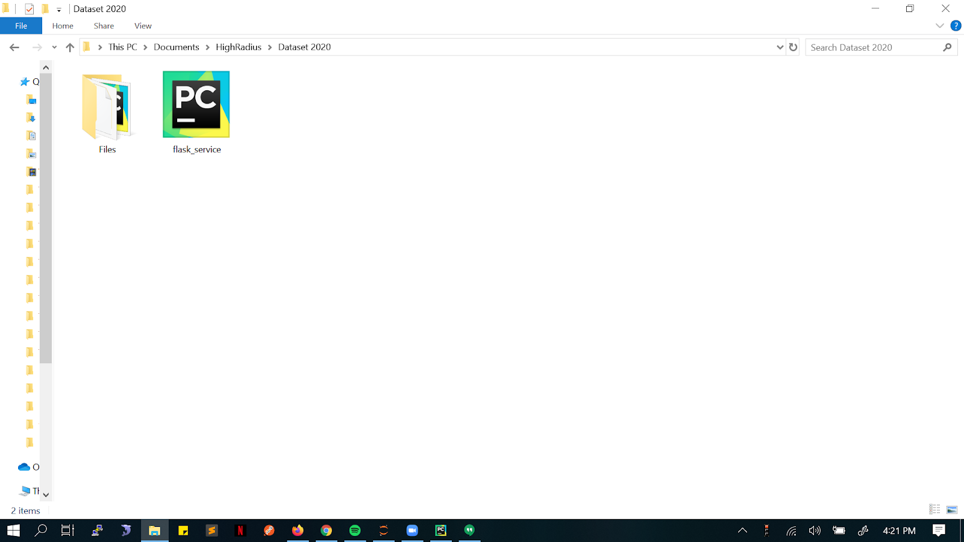
5. Inside **Files** Folder, there should be two things present ->
   1. Pickle File (Incase you don't have pickle library, pip install pickle):

import pickle

filename = ‘roll_number.pkl’

pickle.dump(model, open(filename, 'wb'))

1. Preprocessing & Feature Engineering Script: roll_number.py

# **Integration:**

1. Just like any python program, In your CMD or Anaconda Prompt whichever available run ***python flask_service***[***.py***](http://flask_service.py). This ***flask_service***[***.py***](http://flask_service.py) command runs a Python file and sets __name__ == "__main__". If the main block calls app.run(), it will run the development server.
2. Flask_service.py is the flask application. Inside it we have a route named **‘/predict’** , which will be called from the client side . The route is responsible for returning the output from the model in the form of a json object.
3. Inside ‘predict’ we instantiate an object of ‘_rollno’ class and call getPredictions function which will return us the result.
4. Inside _rollno class we have written different transformation functions which will do the preprocessing and feature engineering , followed by obtaining predictions from the prebuilt model(roll_no.pkl) and return the predicted value to Flask_service.
5. Once the Flask Server is up and running you can call it from React by using the below function:

export function prediction(data) {

return axios.post(

'http://127.0.0.1:5000/predict?',

{},

{

headers: { 'Content-Type': 'application/json' },

params: {

data: data,

},

}

);

}

11. The format of the data sent should be:

**{**

**"id": "<ROLL_NO>",**

**"data": [**

**{**

**.......**

**},**

**{**

**.......**

**}**

**]**

**}**